NPI demo SOP

1. Double-click to execute “AVCP.exe” (C:\Program Files\AVCP\AVCP.exe)

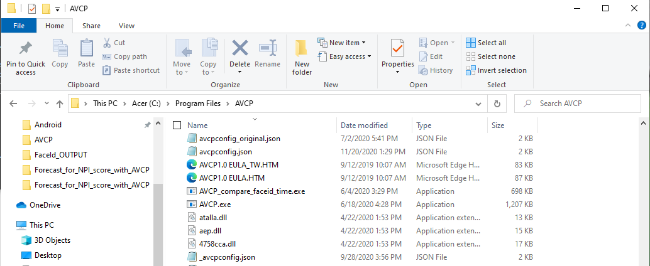

1. Wait for the console to display "api initialization"

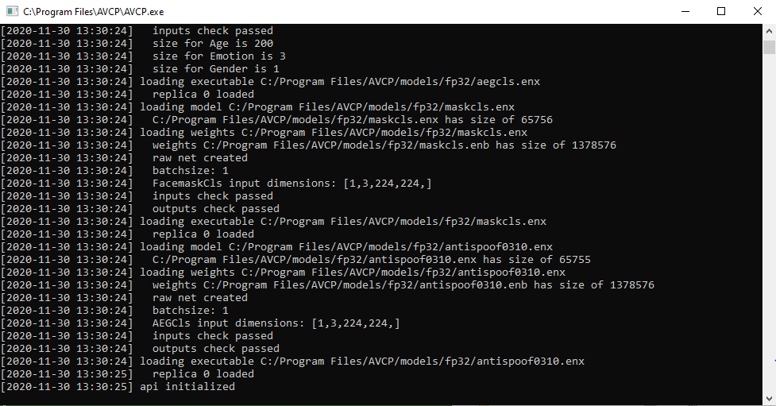

1. Double-click to execute “client_webcam_match.py” (Desktop\ Forecast_for_NPI_score_with_AVCP\ client_webcam_match.py)

